MLA0105- ARTIFICIAL INTELLIGENCE AND EXPERT SYSTEMS
Experiment-8: Backward Chaining on a set of Horn clauses.
rules = [
("vertebrate(A)", ["mammal(A)"]),
("animal(A)", ["vertebrate(A)"]),
("bird(A)", ["vertebrate(A)", "flying(A)"])
]
facts = [
'vertebrate("duck")',
'flying("duck")',
'mammal("cat")'
]
def unify(term, fact):
if "(" not in term: # simple fact
return {} if term == fact else None
pred1, arg1 = term.split("(")
arg1 = arg1.rstrip(")")
pred2, arg2 = fact.split("(")
arg2 = arg2.rstrip(")")
if pred1 != pred2:
return None
if arg1.isupper(): # e.g., A
return {arg1: arg2}
elif arg1 == arg2:
return {}
else:
return None
def backward_chain(goal, facts, rules, visited=None):
if visited is None:
visited = set()

if goal in visited:
return False
visited.add(goal)
for fact in facts:
if unify(goal, fact) is not None:
return True
for head, body in rules:
substitution = unify(head, goal)
if substitution is not None:
new_goals = []
for b in body:
if "(" in b:
pred, arg = b.split("(")
arg = arg.rstrip(")")
if arg in substitution:
arg = substitution[arg]
new_goals.append(f"{pred}({arg})")
else:
new_goals.append(b)
# Recursively check all sub-goals
if all(backward_chain(g, facts, rules, visited) for g in new_goals):
return True
return False
if __name__ == "__main__":
print("Backward Chaining using Horn Clauses\n")
while True:
query = input("Enter the goal to prove (e.g., animal(\"cat\")): ")
result = backward_chain(query, facts, rules)
if result:
print(f"Goal '{query}' can be derived from the knowledge base.\n")
else:
print(f"Goal '{query}' cannot be derived from the knowledge base.\n")
cont = input("Do you want to try another goal? (y/n): ")
if cont.lower() != 'y':
break
Output:
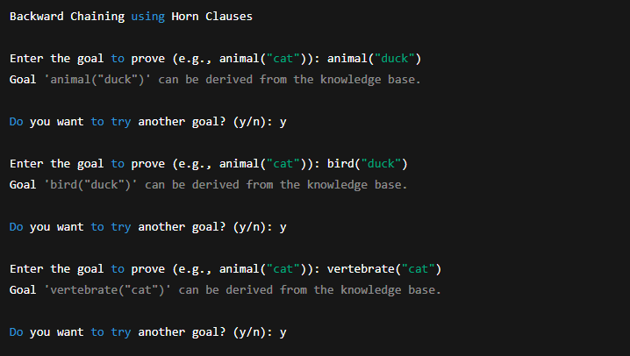

Experiment-8: Feedforward Neural Network. 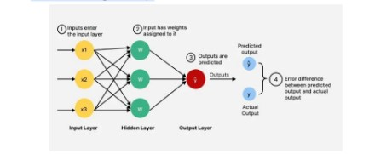
import pygame
import numpy as np
import sys
def sigmoid(x):
return 1 / (1 + np.exp(-x))

class FeedforwardNN:
def __init__(self):
# 2 input → 2 hidden → 1 output
self.w1 = np.random.randn(2, 2)
self.b1 = np.zeros((2,))
self.w2 = np.random.randn(2, 1)
self.b2 = np.zeros((1,))
def forward(self, inputs):
self.z1 = np.dot(inputs, self.w1) + self.b1
self.a1 = sigmoid(self.z1)
self.z2 = np.dot(self.a1, self.w2) + self.b2
self.a2 = sigmoid(self.z2)
return self.a1, self.a2
pygame.init()
WIDTH, HEIGHT = 800, 500
win = pygame.display.set_mode((WIDTH, HEIGHT))
pygame.display.set_caption("Feedforward Neural Network Visualization")
font = pygame.font.SysFont("Arial", 22, bold=True)
WHITE = (255, 255, 255)
BLUE = (60, 120, 255)
BLACK = (0, 0, 0)
nn = FeedforwardNN()
nodes = {
"input": [(250, 180), (250, 300)],
"hidden": [(450, 180), (450, 300)],
"output": [(650, 240)]
}
def draw_node(x, y, value):
pygame.draw.circle(win, BLUE, (x, y), 40)
text = font.render(f"{value:.2f}", True, WHITE)
win.blit(text, (x - text.get_width()//2, y - text.get_height()//2))
def draw_connection(p1, p2):
pygame.draw.line(win, BLACK, p1, p2, 3)
inputs_list = [
np.array([0, 0]),
np.array([0, 1]),
np.array([1, 0]),
np.array([1, 1])
]
index = 0
clock = pygame.time.Clock()
while True:
for event in pygame.event.get():
if event.type == pygame.QUIT:
pygame.quit()
sys.exit()
x_in = inputs_list[index]
hidden_vals, out_val = nn.forward(x_in)
index = (index + 1) % 4
pygame.time.delay(1000)
win.fill(WHITE)
for i_pos in nodes["input"]:
for h_pos in nodes["hidden"]:
draw_connection(i_pos, h_pos)
for h_pos in nodes["hidden"]:
draw_connection(h_pos, nodes["output"][0])
draw_node(nodes["input"][0][0], nodes["input"][0][1], x_in[0])
draw_node(nodes["input"][1][0], nodes["input"][1][1], x_in[1])
draw_node(nodes["hidden"][0][0], nodes["hidden"][0][1], hidden_vals[0])
draw_node(nodes["hidden"][1][0], nodes["hidden"][1][1], hidden_vals[1])

draw_node(nodes["output"][0][0], nodes["output"][0][1], out_val[0])
pygame.display.update()
clock.tick(60)
Output:
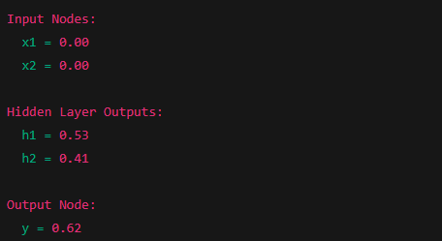

Experiment-10: Checkers AI agent using the Minimax algorithm with Alpha–Beta
pruning.
import copy
import math
import random
EMPTY = "."
RED = "r"
RED_KING = "R"
BLACK = "b"
BLACK_KING = "B"
DIRECTIONS = {
RED: [(-1, -1), (-1, 1)],
BLACK: [(1, -1), (1, 1)],
RED_KING: [(-1,-1),(-1,1),(1,-1),(1,1)],
BLACK_KING: [(-1,-1),(-1,1),(1,-1),(1,1)]
}

def create_board():
board = [[EMPTY]*8 for _ in range(8)]
for i in range(3):
for j in range(8):
if (i+j)%2==1:
board[i][j] = BLACK
for i in range(5,8):
for j in range(8):
if (i+j)%2==1:
board[i][j] = RED
return board
def print_board(board):
print("\n 0 1 2 3 4 5 6 7")
print(" ----------------")
for i, row in enumerate(board):
print(f"{i} | " + " ".join(row))
print()
def in_bounds(r,c):
return 0 <= r < 8 and 0 <= c < 8
def opponent(player):
return RED if player in (BLACK,BLACK_KING) else BLACK
def king(piece):
return piece in (RED_KING, BLACK_KING)
def make_king(piece):
return RED_KING if piece in (RED, RED_KING) else BLACK_KING
def get_all_moves(board, player):
moves = []
captures = []

for r in range(8):
for c in range(8):
if board[r][c].lower() == player:
caps = get_piece_captures(board, r, c)
if caps:
captures.extend(caps)
else:
moves.extend(get_piece_moves(board, r, c))
return captures if captures else moves
def get_piece_moves(board, r, c):
piece = board[r][c]
moves = []
for dr, dc in DIRECTIONS[piece]:
nr, nc = r + dr, c + dc
if in_bounds(nr, nc) and board[nr][nc] == EMPTY:
moves.append(((r,c),(nr,nc)))
return moves
def get_piece_captures(board, r, c):
piece = board[r][c]
captures = []
for dr, dc in DIRECTIONS[piece]:
mid_r, mid_c = r + dr, c + dc
end_r, end_c = r + 2*dr, c + 2*dc
if (in_bounds(mid_r, mid_c) and in_bounds(end_r, end_c) and
board[mid_r][mid_c].lower() == opponent(piece) and
board[end_r][end_c] == EMPTY):
new_board = copy.deepcopy(board)
move_piece(new_board, (r,c), (end_r,end_c))
new_board[mid_r][mid_c] = EMPTY

further = get_piece_captures(new_board, end_r, end_c)
if further:
captures.extend([( (r,c), (end_r,end_c), chain ) for chain in further])
else:
captures.append(((r,c),(end_r,end_c)))
return captures
def move_piece(board, start, end):
(r,c),(nr,nc) = start,end
piece = board[r][c]
board[r][c] = EMPTY
if piece == RED and nr == 0:
piece = RED_KING
if piece == BLACK and nr == 7:
piece = BLACK_KING
board[nr][nc] = piece
def check_winner(board):
red_exists = any(piece in (RED, RED_KING) for row in board for piece in row)
black_exists = any(piece in (BLACK, BLACK_KING) for row in board for piece in row)
if not red_exists:
return "BLACK wins"
if not black_exists:
return "RED wins"
return None
def evaluate(board):
score = 0
for row in board:
for p in row:
if p == RED: score += 1
elif p == RED_KING: score += 2
elif p == BLACK: score -= 1
elif p == BLACK_KING: score -= 2
return score
def minimax(board, depth, alpha, beta, maximizing, player):
win = check_winner(board)
if win or depth == 0:
return evaluate(board), None
moves = get_all_moves(board, player)
if not moves:
return evaluate(board), None
best_move = None
if maximizing:
max_eval = -math.inf
for mv in moves:
new_board = simulate_move(board, mv)
ev, _ = minimax(new_board, depth-1, alpha, beta, False, opponent(player))
if ev > max_eval:
max_eval = ev
best_move = mv
alpha = max(alpha, ev)
if beta <= alpha:
break
return max_eval, best_move
else:
min_eval = math.inf
for mv in moves:
new_board = simulate_move(board, mv)
ev, _ = minimax(new_board, depth-1, alpha, beta, True, opponent(player))
if ev < min_eval:
min_eval = ev
best_move = mv
beta = min(beta, ev)
if beta <= alpha:
break
return min_eval, best_move
def simulate_move(board, move):
new_board = copy.deepcopy(board)
if len(move) == 2:
move_piece(new_board, move[0], move[1])
else:
(r,c),(nr,nc), chain = move
move_piece(new_board, (r,c), (nr,nc))
mid_r = (r+nr)//2
mid_c = (c+nc)//2
new_board[mid_r][mid_c] = EMPTY
return new_board
def play_game():
board = create_board()
print_board(board)
mode = input("Choose mode (1 = Human vs AI, 2 = AI vs AI): ")
current_player = RED
while True:
winner = check_winner(board)
if winner:
print(winner)
break
print(f"{current_player.upper()}'s turn")
print_board(board)
moves = get_all_moves(board, current_player)
if not moves:
print(f"{opponent(current_player).upper()} wins!")
break
if mode == "1" and current_player == RED:
print("Available moves (start_r start_c end_r end_c):")
for mv in moves:
print(mv)
sr = int(input("Start row: "))
sc = int(input("Start col: "))
er = int(input("End row: "))
ec = int(input("End col: "))
chosen = ((sr,sc),(er,ec))
else:
print("AI thinking...")
_, chosen = minimax(board, 4, -math.inf, math.inf, True, current_player)
board = simulate_move(board, chosen)
current_player = opponent(current_player)
play_game()
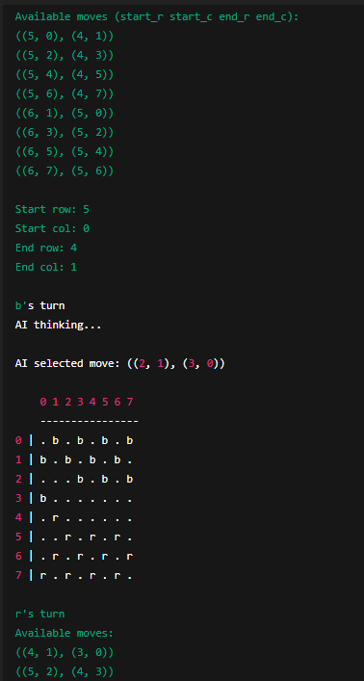
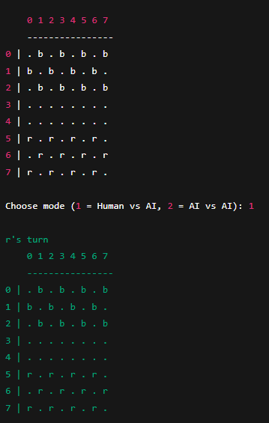
Output:
Experiment-11: build and evaluate a Decision Tree classifier.
dataset = [
['Sunny', 'Hot', 'High', 'False', 'No'],
['Sunny', 'Hot', 'High', 'True', 'No'],
['Overcast', 'Hot', 'High', 'False', 'Yes'],
['Rainy', 'Mild', 'High', 'False', 'Yes'],
['Rainy', 'Cool', 'Normal', 'False', 'Yes'],
['Rainy', 'Cool', 'Normal', 'True', 'No'],
['Overcast', 'Cool', 'Normal', 'True', 'Yes'],
['Sunny', 'Mild', 'High', 'False', 'No'],
['Sunny', 'Cool', 'Normal', 'False', 'Yes'],
['Rainy', 'Mild', 'Normal', 'False', 'Yes'],
['Sunny', 'Mild', 'Normal', 'True', 'Yes'],
['Overcast', 'Mild', 'High', 'True', 'Yes'],
['Overcast', 'Hot', 'Normal', 'False', 'Yes'],
['Rainy', 'Mild', 'High', 'True', 'No']
]
features = ['Outlook', 'Temperature', 'Humidity', 'Windy']
import math
def entropy(rows):
total = len(rows)
yes = len([r for r in rows if r[-1] == 'Yes'])
no = total - yes
if yes == 0 or no == 0:
return 0
p1 = yes / total
p2 = no / total
return -p1 * math.log2(p1) - p2 * math.log2(p2)
def split_dataset(rows, column, value):
set1 = [r for r in rows if r[column] == value]
set2 = [r for r in rows if r[column] != value]
return set1, set2
def best_split(rows):
best_gain = 0
best_column = None
best_value = None
current_entropy = entropy(rows)
n_features = len(rows[0]) - 1
for col in range(n_features):
values = set([r[col] for r in rows])
for v in values:
set1, set2 = split_dataset(rows, col, v)
if len(set1) == 0 or len(set2) == 0:
continue
p = len(set1) / len(rows)
gain = current_entropy - p * entropy(set1) - (1 - p) * entropy(set2)
if gain > best_gain:
best_gain = gain
best_column = col
best_value = v
return best_gain, best_column, best_value
class DecisionNode:
def __init__(self, column=None, value=None, true_branch=None, false_branch=None, result=None):
self.column = column
self.value = value
self.true_branch = true_branch
self.false_branch = false_branch
self.result = result
def build_tree(rows):
gain, column, value = best_split(rows)
if gain == 0:
yes = len([r for r in rows if r[-1] == 'Yes'])
no = len(rows) - yes
return DecisionNode(result='Yes' if yes >= no else 'No')
set1, set2 = split_dataset(rows, column, value)
true_branch = build_tree(set1)
false_branch = build_tree(set2)
return DecisionNode(column, value, true_branch, false_branch)
def print_tree(node, spacing=""):
if node.result is not None:
print(spacing + "Predict:", node.result)
return
print(f"{spacing}{features[node.column]} == {node.value}?")
print(spacing + "-> True:")
print_tree(node.true_branch, spacing + " ")
print(spacing + "-> False:")
print_tree(node.false_branch, spacing + " ")
def classify(observation, node):
if node.result is not None:
return node.result
if observation[node.column] == node.value:
return classify(observation, node.true_branch)
else:
return classify(observation, node.false_branch)
tree = build_tree(dataset)
print("\n=== DECISION TREE STRUCTURE ===\n")
print_tree(tree)
test_data = ['Rainy', 'Mild', 'Normal', 'False'] # Expected Yes
prediction = classify(test_data, tree)

print("\nPrediction for", test_data, "->", prediction)
correct = 0
for row in dataset:
pred = classify(row[:-1], tree)
if pred == row[-1]:
correct += 1
accuracy = correct / len(dataset) * 100
print("\nAccuracy on training data:", accuracy, "%")
Output:
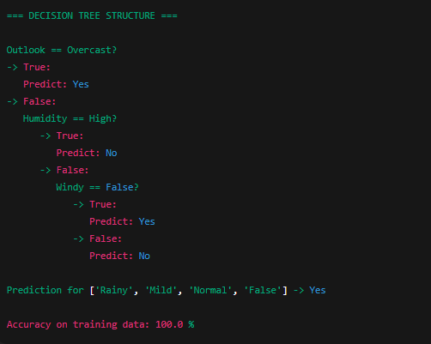

Experiment-12: river-crossing puzzle that involves three missionaries and three cannibals who need to cross a river.
from collections import deque
start_state = (3, 3, 'left')
goal_state = (0, 0, 'right')
def is_valid_state(m_left, c_left, boat_pos):
m_right = 3 - m_left
c_right = 3 - c_left
if not (0 <= m_left <= 3 and 0 <= c_left <= 3):
return False
if (m_left > 0 and m_left < c_left) or (m_right > 0 and m_right < c_right):
return False
return True
def get_successors(state):
m_left, c_left, boat_pos = state
successors = []
moves = [(1, 0), (2, 0), (0, 1), (0, 2), (1, 1)]
for m_move, c_move in moves:
if boat_pos == 'left':
new_state = (m_left - m_move, c_left - c_move, 'right')
else:
new_state = (m_left + m_move, c_left + c_move, 'left')
if is_valid_state(*new_state):
successors.append(new_state)
return successors
def bfs(start, goal):
queue = deque([(start, [start])])
visited = set()
while queue:
current_state, path = queue.popleft()
if current_state == goal:
return path
visited.add(current_state)
for next_state in get_successors(current_state):
if next_state not in visited:
queue.append((next_state, path + [next_state]))
return None
solution = bfs(start_state, goal_state)
if solution:
print("Solution found! Sequence of states:")
for step in solution:
print(step)
else:
print("No solution found.")
Output:
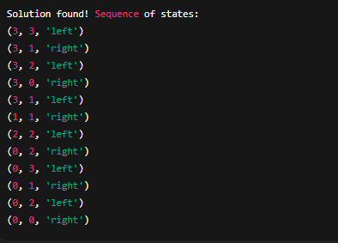

Experiment-13: simulate the Tic Tac Toe game.
import random
def print_board(board):
for row in board:
print(" | ".join(row))
print("-" * 9)
def check_winner(board, player):
for i in range(3):
if all(board[i][j] == player for j in range(3)):
return True
if all(board[j][i] == player for j in range(3)):
return True
if all(board[i][i] == player for i in range(3)):
return True
if all(board[i][2 - i] == player for i in range(3)):
return True
return False
def board_full(board):
return all(board[i][j] != ' ' for i in range(3) for j in range(3))
def human_move(board):
while True:
try:
move = input("Enter your move as row and column (0 1 2) separated by space: ")
row, col = map(int, move.split())
if row in range(3) and col in range(3) and board[row][col] == ' ':
board[row][col] = 'X'
break
else:
print("Invalid move, cell already occupied or out of bounds.")
except:
print("Invalid input. Please enter two numbers separated by space.")
def ai_move(board):
available = [(i, j) for i in range(3) for j in range(3) if board[i][j] == ' ']
if available:
row, col = random.choice(available)
board[row][col] = 'O'
def tic_tac_toe():
board = [[' ' for _ in range(3)] for _ in range(3)]
print_board(board)
while True:
human_move(board)
print_board(board)
if check_winner(board, 'X'):
print("Human wins!")
break
if board_full(board):
print("It's a draw!")
break
ai_move(board)
print("AI's move:")
print_board(board)
if check_winner(board, 'O'):
print("AI wins!")
break
if board_full(board):
print("It's a draw!")
break
if __name__ == "__main__":
tic_tac_toe()

Output:
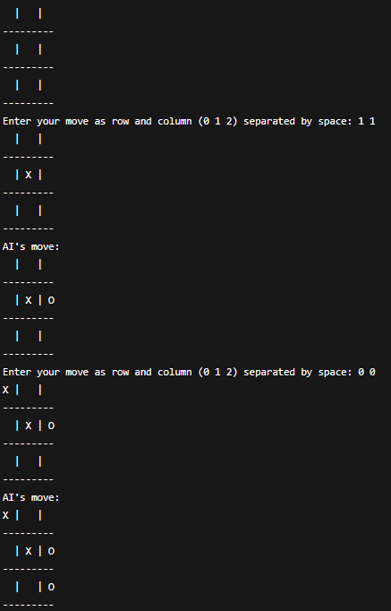

Experiment-14: simple autonomous vacuum cleaner.
import pygame
import random
import sys
pygame.init()
ROWS, COLS = 5, 5
CELL_SIZE = 100
WIDTH, HEIGHT = COLS * CELL_SIZE, ROWS * CELL_SIZE
FPS = 10
WHITE = (240, 240, 240)
BLACK = (0, 0, 0)
GREEN = (0, 200, 0)
BROWN = (139, 69, 19)
BLUE = (0, 120, 255)
GRAY = (180, 180, 180)
screen = pygame.display.set_mode((WIDTH, HEIGHT + 80))
pygame.display.set_caption("🧹 Autonomous Vacuum Cleaner Game")
font = pygame.font.SysFont("arial", 24)
grid = [['.' for _ in range(COLS)] for _ in range(ROWS)]
num_dirty = random.randint(5, 8)
dirty_cells = random.sample([(r, c) for r in range(ROWS) for c in range(COLS)], num_dirty)
for r, c in dirty_cells:
grid[r][c] = 'D'
vacuum_r, vacuum_c = random.choice([(r, c) for r in range(ROWS) for c in range(COLS)])
grid[vacuum_r][vacuum_c] = 'V'
moves = 0
def draw_grid():
for r in range(ROWS):
for c in range(COLS):
x, y = c * CELL_SIZE, r * CELL_SIZE
pygame.draw.rect(screen, GRAY, (x, y, CELL_SIZE, CELL_SIZE), 1)
if grid[r][c] == 'D':
pygame.draw.circle(screen, BROWN, (x + CELL_SIZE//2, y + CELL_SIZE//2), 20)
elif grid[r][c] == 'V':
pygame.draw.rect(screen, BLUE, (x + 25, y + 25, 50, 50), border_radius=10)
pygame.draw.rect(screen, WHITE, (0, HEIGHT, WIDTH, 80))
dirty_count = sum(row.count('D') for row in grid)
text1 = font.render(f"Dirty Cells Left: {dirty_count}", True, BLACK)
text2 = font.render(f"Moves Taken: {moves}", True, BLACK)
screen.blit(text1, (20, HEIGHT + 10))
screen.blit(text2, (20, HEIGHT + 40))
def move_vacuum(dr, dc):
global vacuum_r, vacuum_c, moves
new_r = vacuum_r + dr
new_c = vacuum_c + dc
if 0 <= new_r < ROWS and 0 <= new_c < COLS:
grid[vacuum_r][vacuum_c] = '.'
vacuum_r, vacuum_c = new_r, new_c
if grid[new_r][new_c] == 'D':
grid[new_r][new_c] = 'V'
else:
grid[new_r][new_c] = 'V'
moves += 1
clock = pygame.time.Clock()
running = True
while running:
screen.fill(WHITE)
draw_grid()
pygame.display.flip()
dirty_left = sum(row.count('D') for row in grid)
if dirty_left == 0:
screen.fill(WHITE)
win_text = font.render("✅ All cells are clean! Well done!", True, GREEN)
screen.blit(win_text, (60, HEIGHT // 2 - 30))
pygame.display.flip()
pygame.time.wait(2500)
running = False
continue
for event in pygame.event.get():
if event.type == pygame.QUIT:
pygame.quit()
sys.exit()
elif event.type == pygame.KEYDOWN:
if event.key == pygame.K_UP:
move_vacuum(-1, 0)
elif event.key == pygame.K_DOWN:
move_vacuum(1, 0)
elif event.key == pygame.K_LEFT:
move_vacuum(0, -1)
elif event.key == pygame.K_RIGHT:
move_vacuum(0, 1)
clock.tick(FPS)
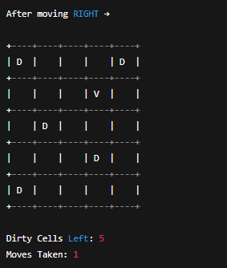
Output:
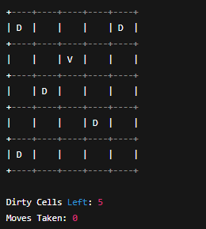

Experiment-15: N-Queens problem using Hill Climbing.
n queens problem using hill climbing
import random
def print_board(state):
n = len(state)
for row in range(n):
line = ""
for col in range(n):
if state[col] == row:
line += "Q "
else:
line += ". "
print(line)
print()
def compute_cost(state):
attacks = 0
n = len(state)
for i in range(n):
for j in range(i + 1, n):
if state[i] == state[j] or abs(state[i] - state[j]) == abs(i - j):
attacks += 1
return attacks
def get_neighbors(state):
neighbors = []
n = len(state)
for col in range(n):
for row in range(n):
if row != state[col]:
new_state = list(state)
new_state[col] = row
neighbors.append(new_state)
return neighbors
def hill_climbing(n, max_restarts=10):
best_overall = None
best_cost = float("inf")
for restart in range(max_restarts):
current = [random.randint(0, n - 1) for _ in range(n)]
current_cost = compute_cost(current)
while True:
neighbors = get_neighbors(current)
neighbor_costs = [compute_cost(neighbor) for neighbor in neighbors]
min_cost = min(neighbor_costs)
if min_cost >= current_cost: # Local optimum
break
best_neighbor = neighbors[neighbor_costs.index(min_cost)]
current, current_cost = best_neighbor, min_cost
if current_cost < best_cost:
best_cost = current_cost
best_overall = current
if best_cost == 0:
break
print("Final Board:")
print_board(best_overall)
print("Final Cost:", best_cost)
if best_cost == 0:
print("✅ Solution Found!")
else:
print("⚠ Local Optimum Reached.")
n = 8
hill_climbing(n)

Output:
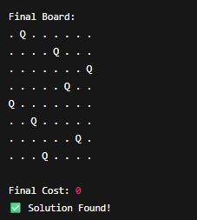
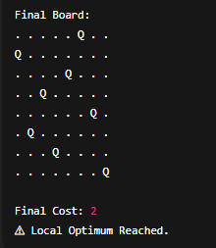
Experiment-16: The goal is to find a valid coloring for the entire map.
import pygame
import sys
import math
pygame.init()
WIDTH, HEIGHT = 800, 600
screen = pygame.display.set_mode((WIDTH, HEIGHT))
pygame.display.set_caption("Map Coloring Game")
FONT = pygame.font.SysFont("arial", 24)
SMALL_FONT = pygame.font.SysFont("arial", 18)
WHITE = (255, 255, 255)
BLACK = (0, 0, 0)
GRAY = (200, 200, 200)
RED = (255, 80, 80)
GREEN = (100, 255, 100)
BLUE = (80, 150, 255)
YELLOW = (255, 255, 100)
COLORS = {"Red": RED, "Green": GREEN, "Blue": BLUE, "Yellow": YELLOW}
color_names = list(COLORS.keys())
graph = {
'A': ['B', 'C', 'D'],
'B': ['A', 'C', 'E'],
'C': ['A', 'B', 'D', 'E'],
'D': ['A', 'C', 'E'],
'E': ['B', 'C', 'D']
}
positions = {
'A': (200, 200),
'B': (400, 100),
'C': (400, 300),
'D': (600, 200),
'E': (500, 400)
}
node_colors = {node: None for node in graph}
selected_color = "Red"
def draw_graph():
screen.fill(WHITE)
for node, neighbors in graph.items():
for neighbor in neighbors:
start = positions[node]
end = positions[neighbor]
pygame.draw.line(screen, BLACK, start, end, 2)
for node, (x, y) in positions.items():
color = node_colors[node]
pygame.draw.circle(screen, BLACK, (x, y), 40)
pygame.draw.circle(screen, color if color else GRAY, (x, y), 35)
text = FONT.render(node, True, BLACK)
screen.blit(text, (x - 10, y - 12))
pygame.draw.rect(screen, GRAY, (50, 450, 700, 100), border_radius=15)
label = FONT.render("Select Color:", True, BLACK)
screen.blit(label, (60, 460))
for i, cname in enumerate(color_names):
rect = pygame.Rect(220 + i * 120, 460, 60, 60)
pygame.draw.rect(screen, COLORS[cname], rect)
if cname == selected_color:
pygame.draw.rect(screen, BLACK, rect, 4)
txt = SMALL_FONT.render(cname, True, BLACK)
screen.blit(txt, (220 + i * 120, 525))
result_text = check_coloring()
result_label = FONT.render(result_text, True, BLACK)
screen.blit(result_label, (300, 550))
pygame.display.flip()
def check_coloring():
for node, neighbors in graph.items():
for n in neighbors:
if node_colors[node] and node_colors[n] == node_colors[node]:
return "❌ Invalid Coloring!"
if all(node_colors[n] for n in node_colors):
return "✅ Valid Coloring!"
return "🟡 In Progress..."
def get_clicked_node(pos):
for node, (x, y) in positions.items():
if math.dist(pos, (x, y)) < 40:
return node
return None
running = True
while running:
draw_graph()
for event in pygame.event.get():
if event.type == pygame.QUIT:
running = False
if event.type == pygame.MOUSEBUTTONDOWN:
mx, my = event.pos
for i, cname in enumerate(color_names):
rect = pygame.Rect(220 + i * 120, 460, 60, 60)
if rect.collidepoint(mx, my):
selected_color = cname
node = get_clicked_node((mx, my))
if node:
node_colors[node] = COLORS[selected_color]
pygame.quit()
sys.exit()
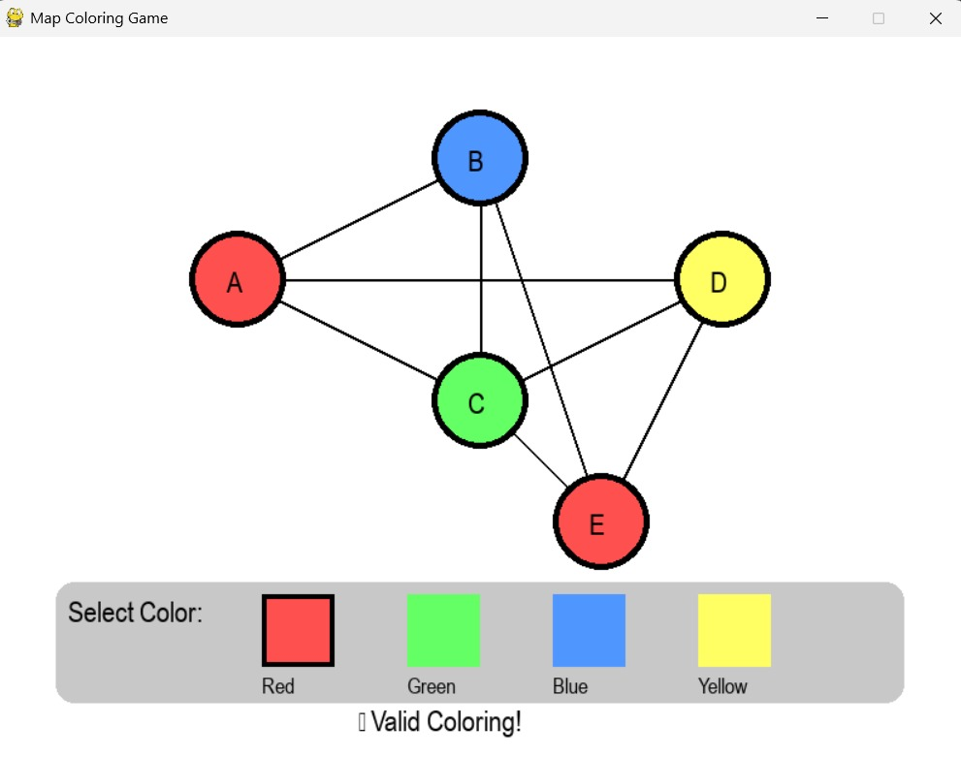

Experiment-17: Consider a game which has 4 final states and paths to reach final state are from root to 4 leaves of a perfect binary tree as shown below. Assume you are the maximizing player and you get the first chance to move, i.e., you are at the root and your opponent at next level. Using python create the program, which move you would make as a maximizing player considering that your opponent also plays optimally?
def minimax(depth, node_index, is_maximizing, values):
if depth == 2:
return values[node_index]
if is_maximizing:
return max(
minimax(depth + 1, node_index * 2, False, values),
minimax(depth + 1, node_index * 2 + 1, False, values)
)
else:
return min(
minimax(depth + 1, node_index * 2, True, values),
minimax(depth + 1, node_index * 2 + 1, True, values)
)
values = [3, 5, 2, 9]
optimal_value = minimax(0, 0, True, values)
print("The optimal value for the maximizing player is:", optimal_value)
left_subtree = min(values[0], values[1]) # Min node under Left
right_subtree = min(values[2], values[3]) # Min node under Right
best_move = "Left" if max(left_subtree, right_subtree) == left_subtree else "Right"
print("The maximizing player should choose:", best_move)
Output:

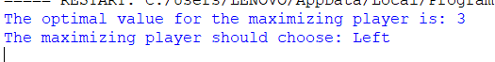

Experiment-18: pathfinding problem using the A* algorithm.
import pygame
import sys
import math
import heapq
pygame.init()
WIDTH, HEIGHT = 800, 600
screen = pygame.display.set_mode((WIDTH, HEIGHT))
pygame.display.set_caption("A* Pathfinding Game")
FONT = pygame.font.SysFont("arial", 24)
SMALL_FONT = pygame.font.SysFont("arial", 18)
WHITE = (255, 255, 255)
BLACK = (0, 0, 0)
GRAY = (200, 200, 200)
BLUE = (80, 150, 255)
GREEN = (100, 255, 100)
YELLOW = (255, 255, 100)
ORANGE = (255, 180, 80)
PURPLE = (180, 100, 255)
RED = (255, 80, 80)
graph = {
'A': {'B': 1, 'C': 4},
'B': {'A': 1, 'D': 3, 'E': 5},
'C': {'A': 4, 'F': 2},
'D': {'B': 3, 'E': 1, 'F': 1},
'E': {'B': 5, 'D': 1, 'F': 2},
'F': {'C': 2, 'D': 1, 'E': 2}
}
positions = {
'A': (150, 250),
'B': (300, 150),
'C': (300, 350),
'D': (500, 150),
'E': (500, 350),
'F': (650, 250)
}
start_node = None
goal_node = None
def heuristic(n1, n2):
(x1, y1), (x2, y2) = positions[n1], positions[n2]
return math.hypot(x2 - x1, y2 - y1)
def astar(start, goal):
open_heap = []
heapq.heappush(open_heap, (0, start))
came_from = {}
g_score = {node: float('inf') for node in graph}
g_score[start] = 0
f_score = {node: float('inf') for node in graph}
f_score[start] = heuristic(start, goal)
visited_order = []
while open_heap:
current = heapq.heappop(open_heap)[1]
visited_order.append(current)
if current == goal:
break
for neighbor, weight in graph[current].items():
tentative_g = g_score[current] + weight
if tentative_g < g_score[neighbor]:
came_from[neighbor] = current
g_score[neighbor] = tentative_g
f_score[neighbor] = tentative_g + heuristic(neighbor, goal)
heapq.heappush(open_heap, (f_score[neighbor], neighbor))

path = []
node = goal
if node not in came_from and node != start:
return visited_order, [], float('inf')
while node in came_from:
path.insert(0, node)
node = came_from[node]
path.insert(0, start)
return visited_order, path, g_score[goal]
def draw_graph(visited=set(), path=set()):
screen.fill(WHITE)
for node, neighbors in graph.items():
for neighbor, weight in neighbors.items():
start_pos = positions[node]
end_pos = positions[neighbor]
pygame.draw.line(screen, GRAY, start_pos, end_pos, 3)
mid_x = (start_pos[0] + end_pos[0]) // 2
mid_y = (start_pos[1] + end_pos[1]) // 2
text = SMALL_FONT.render(str(weight), True, BLACK)
screen.blit(text, (mid_x - 10, mid_y - 10))
for node, (x, y) in positions.items():
color = BLUE
if node in visited:
color = YELLOW
if node in path:
color = GREEN
if node == start_node:
color = ORANGE
if node == goal_node:
color = PURPLE
pygame.draw.circle(screen, BLACK, (x, y), 40)
pygame.draw.circle(screen, color, (x, y), 35)
text = FONT.render(node, True, BLACK)
screen.blit(text, (x - 10, y - 12))
instruction = "Click Start Node" if not start_node else \
"Click Goal Node" if not goal_node else "Pathfinding..."
text_inst = FONT.render(instruction, True, RED)
screen.blit(text_inst, (50, 20))
pygame.display.flip()
def get_clicked_node(pos):
for node, (x, y) in positions.items():
if math.dist(pos, (x, y)) < 40:
return node
return None
running = True
visited_order, final_path, cost = [], [], 0
step = 0 # animation step
while running:
draw_graph(set(visited_order[:step]), set(final_path[:step]))
for event in pygame.event.get():
if event.type == pygame.QUIT:
running = False
if event.type == pygame.MOUSEBUTTONDOWN:
clicked = get_clicked_node(event.pos)
if clicked:
if not start_node:
start_node = clicked
elif not goal_node:
goal_node = clicked
visited_order, final_path, cost = astar(start_node, goal_node)
print("Node Expansion Order:", " → ".join(visited_order))
print("Final Path:", " → ".join(final_path))
print(f"Total Cost: {cost}")
step = 0 # reset animation
if start_node and goal_node and step < len(visited_order):
step += 1
pygame.time.delay(500)
pygame.quit()
sys.exit()
Output:
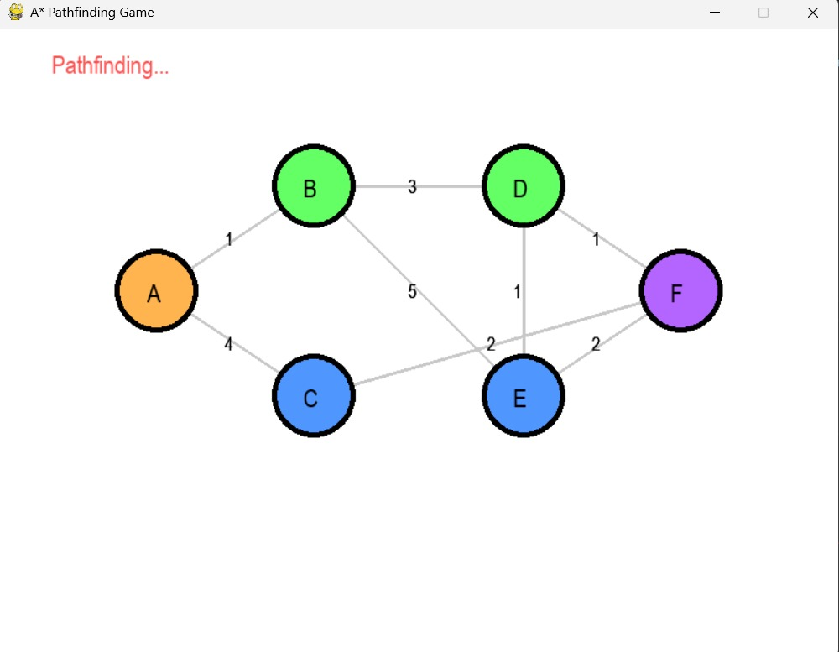

Experiment-19: list of cities and the distances between each pair of cities, the objective is to find the shortest possible route that visits each city exactly once and returns to the original city (the salesman's starting point). Implement the scenario using python.
from itertools import permutations
n = int(input("Enter the number of cities: "))
cities = []
for i in range(n):
city = input(f"Enter city name {i + 1}: ")
cities.append(city)
graph = {}
for city in cities:
graph[city] = {}
print("\nEnter the distances between each pair of cities:")
for i in range(n):
for j in range(i + 1, n):
dist = int(input(f"Distance between {cities[i]} and {cities[j]}: "))
graph[cities[i]][cities[j]] = dist
graph[cities[j]][cities[i]] = dist
start = input("\nEnter the starting city: ")
shortest_distance = float('inf')
best_route = []
for perm in permutations([city for city in cities if city != start]):
route = [start] + list(perm) + [start]
distance = 0
for i in range(len(route) - 1):
distance += graph[route[i]][route[i + 1]]
if distance < shortest_distance:
shortest_distance = distance
best_route = route
print("\nShortest Route:", " -> ".join(best_route))
print("Total Distance:", shortest_distance)
Output:
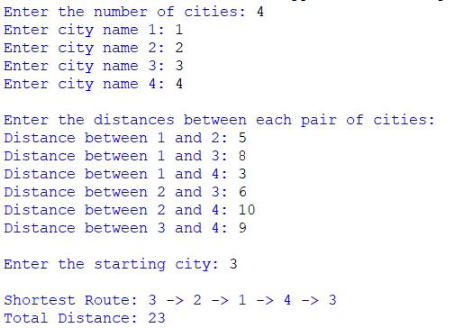

Experiment-20: a simple scheduling problem using the Simulated Annealing
Algorithm.
import random
import math
from collections import defaultdict

random.seed(42)

# ----------------------------
# Problem definition
# ----------------------------
tasks = ["A", "B", "C", "D", "E", "F"]
num_slots = 3
slot_capacity = 2 # max allowed tasks per slot (soft constraint)

# Define conflict pairs (these tasks should not be scheduled in the same slot)
# For example: A conflicts with B, C conflicts with D, E conflicts with F
conflicts = {("A","B"), ("B","A"), ("C","D"), ("D","C"), ("E","F"), ("F","E")}

# Weights in cost function
WEIGHT_CONFLICT = 10 # penalty per conflicting pair in same slot
WEIGHT_CAPACITY = 5 # penalty per task exceeding slot capacity
WEIGHT_LOAD_IMBALANCE = 1 # optional: penalty for load imbalance across slots

# ----------------------------
# Helper: cost function
# ----------------------------
def schedule_cost(schedule):
"""
schedule: dict task -> slot_index
Returns a scalar cost (lower is better).
"""
# Build slot -> tasks
slots = defaultdict(list)
for t, s in schedule.items():
slots[s].append(t)

cost = 0

# Conflict penalties
for s_tasks in slots.values():
n = len(s_tasks)
if n <= 1:
continue
# every unique pair among s_tasks
for i in range(n):
for j in range(i+1, n):
t1, t2 = s_tasks[i], s_tasks[j]
if (t1, t2) in conflicts:
cost += WEIGHT_CONFLICT

# Capacity penalties (soft)
for s_idx in range(num_slots):
count = len(slots.get(s_idx, []))
if count > slot_capacity:
cost += (count - slot_capacity) * WEIGHT_CAPACITY

# Load imbalance penalty (encourage balanced schedules)
loads = [len(slots.get(i, [])) for i in range(num_slots)]
avg = sum(loads) / num_slots
variance = sum((l - avg)**2 for l in loads) / num_slots
cost += WEIGHT_LOAD_IMBALANCE * variance

return cost

# ----------------------------
# Generate initial random schedule
# ----------------------------
def random_schedule():
sched = {}
for t in tasks:
sched[t] = random.randrange(num_slots)
return sched

# ----------------------------
# Neighbor generation
# ----------------------------
def neighbor(schedule):
new = schedule.copy()
if random.random() < 0.5:
# Move: pick one task and assign to a different slot
t = random.choice(tasks)
new_slot = random.randrange(num_slots)
# ensure actually a change
if new_slot == schedule[t]:
new_slot = (new_slot + 1) % num_slots
new[t] = new_slot
else:
# Swap: pick two tasks and swap their slots
t1, t2 = random.sample(tasks, 2)
new[t1], new[t2] = new[t2], new[t1]
return new

# ----------------------------
# Simulated Annealing core
# ----------------------------
def simulated_annealing(
initial_temp=10.0,
final_temp=1e-3,
alpha=0.995,
max_iter=5000
):
current = random_schedule()
current_cost = schedule_cost(current)
best = current.copy()
best_cost = current_cost

T = initial_temp
iter_count = 0

while T > final_temp and iter_count < max_iter:
candidate = neighbor(current)
cand_cost = schedule_cost(candidate)
delta = cand_cost - current_cost

accept = False
if delta <= 0:
accept = True
else:
p = math.exp(-delta / T)
if random.random() < p:
accept = True

if accept:
current, current_cost = candidate, cand_cost

# update best
if current_cost < best_cost:
best, best_cost = current.copy(), current_cost

# Cooling
T *= alpha
iter_count += 1

return best, best_cost

# ----------------------------
# Pretty-print schedule
# ----------------------------
def print_schedule(schedule):
slots = defaultdict(list)
for t, s in schedule.items():
slots[s].append(t)
print("Schedule (slot -> tasks):")
for s in range(num_slots):
print(f" Slot {s}: {slots.get(s, [])}")

# ----------------------------
# Run
# ----------------------------
if __name__ == "__main__":
print("Initial problem setup:")
print(f" Tasks: {tasks}")
print(f" Num slots: {num_slots}, slot capacity: {slot_capacity}")
print(f" Conflicts: {sorted(set(tuple(sorted(p)) for p in conflicts if p[0]<p[1]))}\n")

best_sched, best_cost = simulated_annealing(
initial_temp=10.0,
final_temp=1e-3,
alpha=0.995,
max_iter=20000
)

print("\nBest schedule found:")
print_schedule(best_sched)
print(f"Cost = {best_cost:.3f}")

Output:
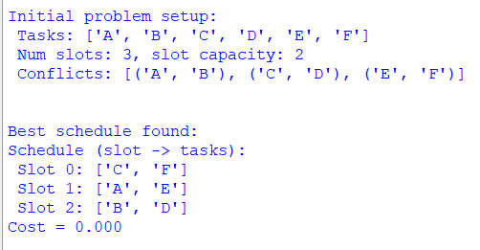

Experiment-21:Knight’s Tour problem using backtracking.
CODE:
# Knight's Tour using Backtracking
N = 8 # size of chessboard (8x8)
def print_solution(board):
for row in board:
print(' '.join(str(cell).rjust(2, ' ') for cell in row))
print()
# Check if (x, y) is a valid move
def is_safe(x, y, board):
return 0 <= x < N and 0 <= y < N and board[x][y] == -1
# Recursive utility to solve Knight's Tour
def solve_knight_tour(x, y, movei, board, x_move, y_move):
# Base case: if all squares are visited
if movei == N * N:
return True

# Try all possible moves from current coordinate (x, y)
for k in range(8):
next_x = x + x_move[k]
next_y = y + y_move[k]
if is_safe(next_x, next_y, board):
board[next_x][next_y] = movei
if solve_knight_tour(next_x, next_y, movei + 1, board, x_move, y_move):
return True
# Backtrack
board[next_x][next_y] = -1
return False

def knight_tour():
# Initialize board
board = [[-1 for _ in range(N)] for _ in range(N)]
# Moves for the knight
x_move = [2, 1, -1, -2, -2, -1, 1, 2]
y_move = [1, 2, 2, 1, -1, -2, -2, -1]

# Start position
board[0][0] = 0

# Start solving from (0, 0)
if not solve_knight_tour(0, 0, 1, board, x_move, y_move):
print("No solution exists.")
else:
print("Knight's Tour Solution Path:")
print_solution(board)

# Run the program
knight_tour()

OUTPUT:
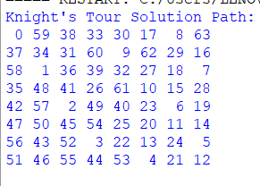

Experiment-22: Uniform-Cost Search (UCS) on a weighted graph and validate
its optimality.
CODE
import heapq
def uniform_cost_search(graph, start, goal):
queue, visited = [(0, start, [])], set()
while queue:
cost, node, path = heapq.heappop(queue)
if node == goal:
return path + [node], cost
if node not in visited:
visited.add(node)
for neighbor, w in graph.get(node, []):
heapq.heappush(queue, (cost + w, neighbor, path + [node]))
return None, float('inf')
def dijkstra(graph, start, goal):
queue, visited = [(0, start, [])], set()
while queue:
cost, node, path = heapq.heappop(queue)
if node == goal:
return path + [node], cost
if node not in visited:
visited.add(node)
for neighbor, w in graph.get(node, []):
heapq.heappush(queue, (cost + w, neighbor, path + [node]))
return None, float('inf')
graph = {
'C': [('A', 1)],
'A': [('F', 4), ('B', 3)],
'F': [('B', 2), ('G', 1)],
'B': [('D', 2), ('E', 5), ('G', 7)],
'D': [('G', 1)],
'E': [('G', 2)],
'G': []
}

ucs_path, ucs_cost = uniform_cost_search(graph, 'C', 'G')
dij_path, dij_cost = dijkstra(graph, 'C', 'G')
print(f"UCS: Path = {ucs_path}, Cost = {ucs_cost}")
print(f"Dijkstra: Path = {dij_path}, Cost = {dij_cost}")

OUTPUT:
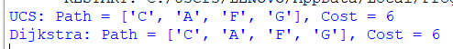

Experiment-23: simulate bilateral negotiation with alternating offers and
discounting.
CODE:
"""
Negotiation simulation (alternating offers with discounting) in Pygame

Save as negotiation_pygame.py and run:
python negotiation_pygame.py

Controls (mouse):
- Click the + / - buttons to change delta1/delta2 and max rounds
- Click Start to run the negotiation animation
- Click Reset to reset parameters

The simulation computes the subgame-perfect offers via backward induction (finite horizon)
and animates each round showing the proposer, the offer, acceptance, and final outcome.

Requires: pygame (install via pip install pygame)
"""

import pygame
import sys
import math
from dataclasses import dataclass

# ---- Model parameters ----
R = 100.0

# ---- Backward induction and simulation (same logic as prior text-based version) ----

def compute_backwards(max_rounds: int, delta1: float, delta2: float):
S1 = [(0.0, 0.0) for _ in range(max_rounds + 2)]
S2 = [(0.0, 0.0) for _ in range(max_rounds + 2)]
for t in range(max_rounds, 0, -1):
cont_v2 = S2[t + 1][1]
denom2 = (delta2 ** (t - 1)) if delta2 > 0 else 0.0
if denom2 > 0:
a2_min = cont_v2 / denom2
else:
a2_min = float('inf')
if a2_min <= R:
v1 = (delta1 ** (t - 1)) * (R - a2_min)
v2 = cont_v2
S1[t] = (v1, v2)
else:
S1[t] = S2[t + 1]

cont_v1 = S1[t + 1][0]
denom1 = (delta1 ** (t - 1)) if delta1 > 0 else 0.0
if denom1 > 0:
a1_min = cont_v1 / denom1
else:
a1_min = float('inf')
if a1_min <= R:
v2 = (delta2 ** (t - 1)) * (R - a1_min)
v1 = cont_v1
S2[t] = (v1, v2)
else:
S2[t] = S1[t + 1]
return S1, S2

@dataclass
class RoundState:
round_no: int
proposer: str
offer: tuple | None
accepted: bool

def simulate_steps(max_rounds, delta1, delta2, starter='player1'):
S1, S2 = compute_backwards(max_rounds, delta1, delta2)
history = []
current = starter
for t in range(1, max_rounds + 1):
if current == 'player1':
cont_v2 = S2[t + 1][1]
denom2 = (delta2 ** (t - 1)) if delta2 > 0 else 0.0
a2_min = cont_v2 / denom2 if denom2 > 0 else float('inf')
if a2_min <= R:
a2 = max(0.0, min(R, a2_min))
a1 = R - a2
offer = (a1, a2)
history.append(RoundState(t, 'player1', offer, True))
return history
else:
history.append(RoundState(t, 'player1', None, False))
current = 'player2'
else:
cont_v1 = S1[t + 1][0]
denom1 = (delta1 ** (t - 1)) if delta1 > 0 else 0.0
a1_min = cont_v1 / denom1 if denom1 > 0 else float('inf')
if a1_min <= R:
a1 = max(0.0, min(R, a1_min))
a2 = R - a1
offer = (a1, a2)
history.append(RoundState(t, 'player2', offer, True))
return history
else:
history.append(RoundState(t, 'player2', None, False))
current = 'player1'
return history

# ---- Pygame UI ----

pygame.init()
WIDTH, HEIGHT = 900, 600
screen = pygame.display.set_mode((WIDTH, HEIGHT))
pygame.display.set_caption('Alternating Offers Negotiation (Discounting)')
FONT = pygame.font.SysFont('Arial', 18)
BIGFONT = pygame.font.SysFont('Arial', 24)
CLOCK = pygame.time.Clock()

# Colors
WHITE = (255, 255, 255)
BLACK = (0, 0, 0)
GRAY = (200, 200, 200)
LIGHTGRAY = (230, 230, 230)
GREEN = (44, 160, 44)
RED = (214, 39, 40)
BLUE = (31, 119, 180)

# UI state
delta1 = 0.95
delta2 = 0.90
max_rounds = 15
starter = 'player1'

running_sim = False
sim_history = []
current_step_index = 0
step_timer = 0.0
STEP_DELAY = 1000 # ms between steps

# Buttons and rectangles
start_btn_rect = pygame.Rect(700, 480, 160, 40)
reset_btn_rect = pygame.Rect(700, 530, 160, 40)
plus1_rect = pygame.Rect(240, 80, 30, 30)
minus1_rect = pygame.Rect(200, 80, 30, 30)
plus2_rect = pygame.Rect(240, 140, 30, 30)
minus2_rect = pygame.Rect(200, 140, 30, 30)
plusR_rect = pygame.Rect(240, 200, 30, 30)
minusR_rect = pygame.Rect(200, 200, 30, 30)
starter_toggle_rect = pygame.Rect(200, 260, 120, 30)

def draw_text(text, x, y, font=FONT, color=BLACK):
surf = font.render(text, True, color)
screen.blit(surf, (x, y))

def draw_ui():
# background
screen.fill(WHITE)
# Title
draw_text('Alternating-offers Negotiation (Discounted)', 20, 10, BIGFONT)

# Parameter panel
pygame.draw.rect(screen, LIGHTGRAY, (180, 60, 360, 260))
draw_text('Parameters:', 190, 65, BIGFONT)
# delta1
draw_text('Player1 discount (delta1):', 200, 85)
pygame.draw.rect(screen, GRAY, minus1_rect)
draw_text('-', minus1_rect.x + 9, minus1_rect.y + 5, BIGFONT)
pygame.draw.rect(screen, GRAY, plus1_rect)
draw_text('+', plus1_rect.x + 8, plus1_rect.y + 5, BIGFONT)
draw_text(f'{delta1:.4f}', 290, 85)

# delta2
draw_text('Player2 discount (delta2):', 200, 145)
pygame.draw.rect(screen, GRAY, minus2_rect)
draw_text('-', minus2_rect.x + 9, minus2_rect.y + 5, BIGFONT)
pygame.draw.rect(screen, GRAY, plus2_rect)
draw_text('+', plus2_rect.x + 8, plus2_rect.y + 5, BIGFONT)
draw_text(f'{delta2:.4f}', 290, 145)

# max rounds
draw_text('Max rounds:', 200, 205)
pygame.draw.rect(screen, GRAY, minusR_rect)
draw_text('-', minusR_rect.x + 9, minusR_rect.y + 5, BIGFONT)
pygame.draw.rect(screen, GRAY, plusR_rect)
draw_text('+', plusR_rect.x + 8, plusR_rect.y + 5, BIGFONT)
draw_text(f'{max_rounds}', 290, 205)

# starter
pygame.draw.rect(screen, GRAY, starter_toggle_rect)
draw_text(f'Starter: {starter}', starter_toggle_rect.x + 6, starter_toggle_rect.y + 6)

# Buttons
pygame.draw.rect(screen, BLUE if not running_sim else GRAY, start_btn_rect)
draw_text('Start / Run', start_btn_rect.x + 30, start_btn_rect.y + 12, FONT, WHITE if not running_sim else BLACK)
pygame.draw.rect(screen, RED, reset_btn_rect)
draw_text('Reset', reset_btn_rect.x + 60, reset_btn_rect.y + 12, FONT, WHITE)

# Display negotiation panel
pygame.draw.rect(screen, LIGHTGRAY, (20, 340, 660, 240))
draw_text('Negotiation timeline & outcome:', 30, 345, BIGFONT)

# If simulation has steps, draw them
y0 = 380
if not sim_history:
draw_text('No simulation yet. Adjust parameters and click Start.', 30, y0)
else:
# show up to first 8 rounds
for i, rs in enumerate(sim_history[:8]):
y = y0 + i * 28
text = f"Round {rs.round_no}: Proposer={rs.proposer}"
if rs.offer is None:
text += ' -> Offered nothing (rejected)'
else:
a1, a2 = rs.offer
text += f' -> Offer: P1={a1:.2f}, P2={a2:.2f}'
text += ' [ACCEPT]' if rs.accepted else ' [REJECT]'
draw_text(text, 30, y)

# If agreement reached, display final outcome summary to the right
if sim_history and any(r.accepted for r in sim_history):
# find first accepted
accepted_rounds = [r for r in sim_history if r.accepted]
first = accepted_rounds[0]
a1, a2 = first.offer
# discounted utilities based on round
u1 = (delta1 ** (first.round_no - 1)) * a1
u2 = (delta2 ** (first.round_no - 1)) * a2
draw_text('Final Agreement:', 700, 60, BIGFONT)
draw_text(f'Round: {first.round_no}', 700, 100)
draw_text(f'Proposer: {first.proposer}', 700, 130)
draw_text(f'Allocation: P1={a1:.4f}, P2={a2:.4f}', 700, 160)
draw_text(f'Discounted utilities: U1={u1:.4f}, U2={u2:.4f}', 700, 190)
fair_tol = 5.0
if abs(a1 - R/2) <= fair_tol and abs(a2 - R/2) <= fair_tol:
draw_text('Outcome resembles Nash-like fair (≈50-50)', 700, 220, FONT, GREEN)
else:
draw_text('Outcome NOT close to 50-50 (proposer advantage)', 700, 220, FONT, RED)

def run_simulation():
global sim_history, running_sim, current_step_index, step_timer
sim_history = simulate_steps(max_rounds, delta1, delta2, starter)
running_sim = True
current_step_index = 0
step_timer = pygame.time.get_ticks()

def reset_sim():
global sim_history, running_sim, current_step_index
sim_history = []
running_sim = False
current_step_index = 0

# Helpers for button clicks

def inside(rect, pos):
return rect.collidepoint(pos)

# Main loop

def main_loop():
global delta1, delta2, max_rounds, starter, running_sim, current_step_index, step_timer
while True:
for event in pygame.event.get():
if event.type == pygame.QUIT:
pygame.quit()
sys.exit()
elif event.type == pygame.MOUSEBUTTONDOWN and event.button == 1:
pos = event.pos
if inside(start_btn_rect, pos):
run_simulation()
elif inside(reset_btn_rect, pos):
reset_sim()
elif inside(plus1_rect, pos):
delta1 = min(0.9999, delta1 + 0.01)
elif inside(minus1_rect, pos):
delta1 = max(0.01, delta1 - 0.01)
elif inside(plus2_rect, pos):
delta2 = min(0.9999, delta2 + 0.01)
elif inside(minus2_rect, pos):
delta2 = max(0.01, delta2 - 0.01)
elif inside(plusR_rect, pos):
max_rounds = min(200, max_rounds + 1)
elif inside(minusR_rect, pos):
max_rounds = max(1, max_rounds - 1)
elif inside(starter_toggle_rect, pos):
starter = 'player2' if starter == 'player1' else 'player1'

# update running simulation animation by stepping through history
if running_sim and sim_history:
now = pygame.time.get_ticks()
if now - step_timer >= STEP_DELAY:
# advance to next displayed step if any; here we simply ensure the history is visible -
# since simulate_steps returns only until agreement (or empty), we keep running_sim True
# for a short while then stop
current_step_index += 1
step_timer = now
# stop if we've shown all steps
if current_step_index >= len(sim_history):
running_sim = False

draw_ui()
pygame.display.flip()
CLOCK.tick(30)

if __name__ == '__main__':
main_loop()

OUTPUT:
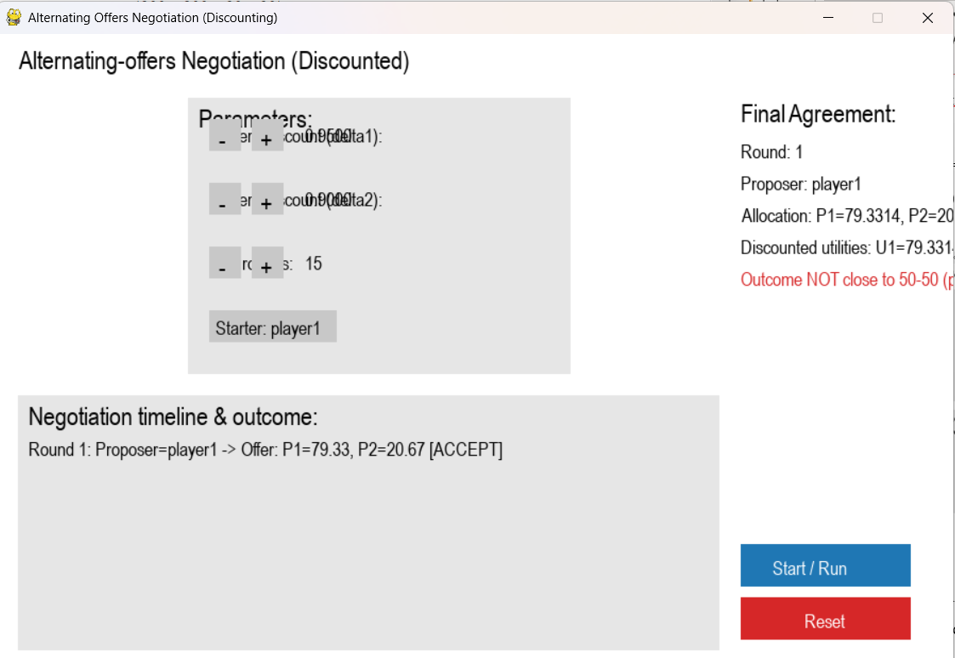

Experiment-24: demonstrate the Expectiminimax algorithm for a stochastic game.
CODE:
def expectiminimax(node, node_type, tree, probabilities=None):
# Leaf node
if isinstance(tree[node], int):
return tree[node]
# MAX node
if node_type == 'max':
return max(expectiminimax(child, tree['types'][child], tree, probabilities) for child in tree[node])
# MIN node
if node_type == 'min':
return min(expectiminimax(child, tree['types'][child], tree, probabilities) for child in tree[node])
# CHANCE node
if node_type == 'chance':
prob_list = probabilities[node]
return sum(
prob * expectiminimax(child, tree['types'][child], tree, probabilities)
for child, prob in zip(tree[node], prob_list)
)

# Example tree structure from the image:
# Root (MAX) --> Chance Node --> Leaf1, Leaf2
# Hit Node --> Leaf3, Leaf4

tree = {
'Root': ['Chance', 'Hit'],
'types': {'Root': 'max', 'Chance': 'chance', 'Hit': 'min', 'Leaf1': 'leaf', 'Leaf2': 'leaf', 'Leaf3': 'leaf', 'Leaf4': 'leaf'},
'Chance': ['Leaf1', 'Leaf2'],
'Hit': ['Leaf3', 'Leaf4'],
'Leaf1': 5,
'Leaf2': 12,
'Leaf3': 15,
'Leaf4': 8
}

# Probabilities for the chance node from the edge labels in the image
probabilities = {
'Chance': [0.5, 0.5] # Probability for Leaf1 and Leaf2
}

# Compute expected utility for both children of the root node
chance_utility = expectiminimax('Chance', tree['types']['Chance'], tree, probabilities)
hit_utility = expectiminimax('Hit', tree['types']['Hit'], tree, probabilities)

print(f"Expected utility of 'Chance' node: {chance_utility}")
print(f"Utility of 'Hit' node (MIN): {hit_utility}")

# Optimal decision at the root (MAX node)
if chance_utility > hit_utility:
print("AI should choose the Chance node.")
else:
print("AI should choose the Hit node.")

print("Randomness affects the choice because the Chance node utility is an average, not a fixed value.")

OUTPUT:
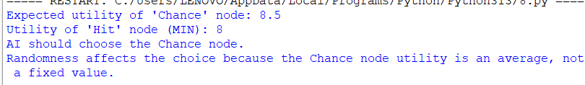
Experiment-25: to solve a pathfinding problem using Beam Search.
CODE:
from queue import Queue
import heapq

# ----------- Graph Representation -----------
graph = {
'A': {'B': 2, 'C': 4},
'B': {'D': 7, 'E': 3},
'C': {'F': 4, 'G': 5},
'D': {'H': 1},
'E': {'H': 6},
'F': {'G': 2, 'H': 5},
'G': {'H': 3},
'H': {}
}

# ----------- Heuristic Function -----------
# (Straight-line distance or estimated cost to goal)
heuristic = {
'A': 10,
'B': 8,
'C': 7,
'D': 4,
'E': 5,
'F': 3,
'G': 2,
'H': 0
}

# ----------- Beam Search Implementation -----------
def beam_search(start, goal, beam_width):
print(f"\n--- Beam Search (Beam width = {beam_width}) ---")
beam = [(heuristic[start], [start])]
level = 0

while beam:
print(f"\nLevel {level}: Candidates -> {[path[-1] for (_, path) in beam]}")
new_beam = []
for _, path in beam:
node = path[-1]
if node == goal:
print("Goal reached!")
return path
for neighbor, cost in graph[node].items():
new_path = path + [neighbor]
score = heuristic[neighbor]
heapq.heappush(new_beam, (score, new_path))

# Keep only k best nodes
beam = heapq.nsmallest(beam_width, new_beam)
level += 1

print("Goal not found (beam too narrow).")
return None

# ----------- Breadth-First Search (for comparison) -----------
def bfs(start, goal):
print("\n--- Breadth-First Search ---")
visited = set()
queue = Queue()
queue.put([start])

while not queue.empty():
path = queue.get()
node = path[-1]

if node == goal:
return path

if node not in visited:
visited.add(node)
for neighbor in graph[node]:
new_path = path + [neighbor]
queue.put(new_path)

return None

# ----------- Main Function -----------
if __name__ == "__main__":
start = 'A'
goal = 'H'
beam_width = 2 # you can change this to 1, 2, 3, etc.

beam_result = beam_search(start, goal, beam_width)
bfs_result = bfs(start, goal)

print("\nBeam Search Path:", beam_result)
print("BFS Path:", bfs_result)

# ----------- Efficiency vs Completeness Discussion -----------
print("\n--- Comparison ---")
print("Beam Search:")
print("- Faster, memory-efficient, but may miss optimal path if beam width is too small.")
print("BFS:")
print("- Guarantees the shortest path but explores all nodes (less efficient).")

OUTPUT:
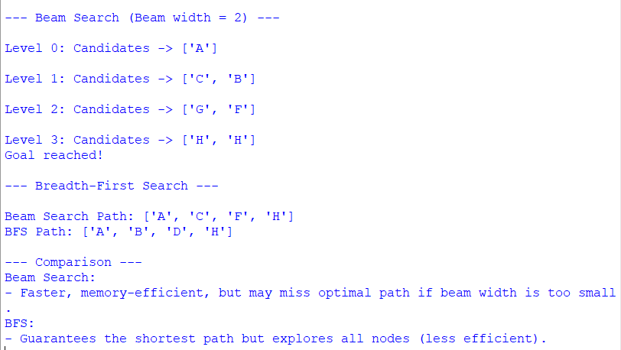
Experiment-26: to solve Sudoku as a Constraint Satisfaction Problem using
backtracking search with constraint checking.
CODE:
# Sudoku Solver using Backtracking and Constraint Checking
N = 9 # Sudoku grid size (9x9)

# Function to print the Sudoku grid
def print_grid(grid):
for i in range(N):
for j in range(N):
print(grid[i][j], end=" ")
print()

# Check if placing num at grid[row][col] is valid
def is_safe(grid, row, col, num):
# Row constraint
if num in grid[row]:
return False

# Column constraint
for i in range(N):
if grid[i][col] == num:
return False

# 3x3 Subgrid constraint
start_row = row - row % 3
start_col = col - col % 3
for i in range(3):
for j in range(3):
if grid[start_row + i][start_col + j] == num:
return False

return True

# Find the next empty cell (returns tuple of row, col)
def find_empty_location(grid):
for i in range(N):
for j in range(N):
if grid[i][j] == 0:
return (i, j)
return None

# Backtracking function to solve Sudoku
def solve_sudoku(grid):
empty = find_empty_location(grid)
if not empty:
return True # Puzzle solved

row, col = empty

for num in range(1, 10): # Try numbers 1–9
if is_safe(grid, row, col, num):
grid[row][col] = num # Assign value

if solve_sudoku(grid): # Recursive step
return True

# Backtrack
grid[row][col] = 0

return False

# -------- Main Program --------
if __name__ == "__main__":
# Example Sudoku puzzle (0 = empty)
sudoku_grid = [
[5, 3, 0, 0, 7, 0, 0, 0, 0],
[6, 0, 0, 1, 9, 5, 0, 0, 0],
[0, 9, 8, 0, 0, 0, 0, 6, 0],
[8, 0, 0, 0, 6, 0, 0, 0, 3],
[4, 0, 0, 8, 0, 3, 0, 0, 1],
[7, 0, 0, 0, 2, 0, 0, 0, 6],
[0, 6, 0, 0, 0, 0, 2, 8, 0],
[0, 0, 0, 4, 1, 9, 0, 0, 5],
[0, 0, 0, 0, 8, 0, 0, 7, 9]
]

print("Original Sudoku Puzzle:")
print_grid(sudoku_grid)
print("\nSolving...\n")

if solve_sudoku(sudoku_grid):
print("Solved Sudoku Grid:")
print_grid(sudoku_grid)
else:
print("No solution exists.")

OUTPUT:
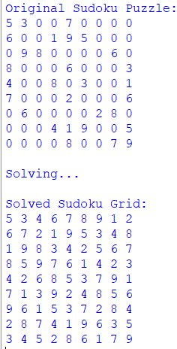
Experiment-27: to solve a Grid-World navigation problem using Q-Learning.
CODE:
import numpy as np
import random

# Define grid world parameters
rows, cols = 5, 5
obstacles = [(1, 1), (2, 3), (3, 2)]
start = (0, 0)
goal = (4, 4)
actions = [(0, 1), (1, 0), (0, -1), (-1, 0)] # Right, Down, Left, Up
action_names = ['R', 'D', 'L', 'U']
step_penalty = -1
obstacle_penalty = -10
goal_reward = 20

# Hyperparams
alpha = 0.1 # Learning rate
gamma = 0.9 # Discount factor
epsilon = 0.2 # Exploration rate
episodes = 500 # Training episodes

# Initialize Q-table
Q = np.zeros((rows, cols, len(actions)))

def valid_state(state):
r, c = state
if 0 <= r < rows and 0 <= c < cols and state not in obstacles:
return True
return False

def get_next_state(current, action):
next_r, next_c = current[0] + action[0], current[1] + action[1]
next_state = (next_r, next_c)
if not valid_state(next_state):
return current # Invalid move, stay in place
return next_state

# Training loop
for episode in range(episodes):
state = start
while state != goal:
r, c = state
# Explore vs exploit
if random.uniform(0, 1) < epsilon:
a = random.randint(0, 3)
else:
a = np.argmax(Q[r, c])

action = actions[a]
next_state = get_next_state(state, action)
nr, nc = next_state

# Rewards
if next_state == goal:
reward = goal_reward
elif next_state in obstacles:
reward = obstacle_penalty
else:
reward = step_penalty

# Q-Learning update
Q[r, c, a] += alpha * (reward + gamma * np.max(Q[nr, nc]) - Q[r, c, a])

state = next_state

# Print Q-table
print("Learned Q-table (shape:", Q.shape, "):")
print(Q)

# Find optimal path from start to goal
state = start
path = [state]
while state != goal:
r, c = state
a = np.argmax(Q[r, c])
next_state = get_next_state(state, actions[a])
if next_state == state or next_state in path:
# Trapped or loop detected
break
path.append(next_state)
state = next_state

print("Optimal path from start to goal:")
print(path)

OUTPUT:
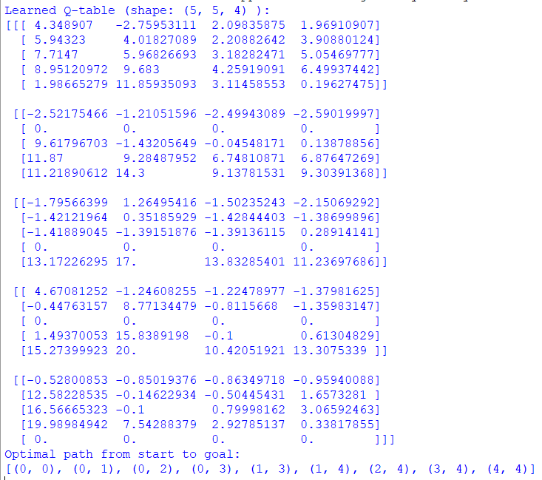

Experiment-28: to solve the Travelling Salesman Problem using Ant Colony
Optimization (ACO).
CODE:
import random

# ---------------- Parameters ----------------
NUM_CITIES = 5
NUM_ANTS = 10
ALPHA = 1.0 # pheromone influence
BETA = 5.0 # distance influence
EVAPORATION = 0.5 # pheromone evaporation rate
Q = 100 # pheromone deposit factor
ITERATIONS = 50

# ---------------- Distance Matrix ----------------
distance_matrix = [
[0, 2, 9, 10, 7],
[1, 0, 6, 4, 3],
[15, 7, 0, 8, 3],
[6, 3, 12, 0, 11],
[9, 7, 5, 6, 0]
]

# ---------------- Initialization ----------------
num_cities = len(distance_matrix)
pheromone = [[1 for _ in range(num_cities)] for _ in range(num_cities)]

# Function to compute total tour length
def tour_length(tour):
length = 0
for i in range(len(tour) - 1):
length += distance_matrix[tour[i]][tour[i + 1]]
length += distance_matrix[tour[-1]][tour[0]] # return to start
return length

# Choose next city based on probability
def select_next_city(current_city, unvisited):
total = 0.0
probabilities = []
for city in unvisited:
pher = pheromone[current_city][city] ** ALPHA
visibility = (1.0 / (distance_matrix[current_city][city] + 1e-10)) ** BETA
score = pher * visibility
probabilities.append((city, score))
total += score

# Normalize probabilities
if total == 0:
return random.choice(list(unvisited))
probabilities = [(city, score / total) for city, score in probabilities]

# Roulette wheel selection
r = random.random()
cumulative = 0.0
for city, prob in probabilities:
cumulative += prob
if r <= cumulative:
return city
return probabilities[-1][0]

# ---------------- Ant Colony Optimization ----------------
def ant_colony_optimization():
global pheromone
best_tour = None
best_length = float('inf')

for iteration in range(ITERATIONS):
all_tours = []

for _ in range(NUM_ANTS):
start = random.randint(0, num_cities - 1)
tour = [start]
unvisited = set(range(num_cities)) - {start}

while unvisited:
current_city = tour[-1]
next_city = select_next_city(current_city, unvisited)
tour.append(next_city)
unvisited.remove(next_city)

all_tours.append(tour)

# Find best tour of this iteration
for tour in all_tours:
length = tour_length(tour)
if length < best_length:
best_length = length
best_tour = tour

# Evaporate pheromone
for i in range(num_cities):
for j in range(num_cities):
pheromone[i][j] *= (1 - EVAPORATION)

# Deposit pheromone
for tour in all_tours:
length = tour_length(tour)
deposit = Q / length
for i in range(len(tour) - 1):
a, b = tour[i], tour[i + 1]
pheromone[a][b] += deposit
pheromone[b][a] += deposit
a, b = tour[-1], tour[0]
pheromone[a][b] += deposit
pheromone[b][a] += deposit

print(f"Iteration {iteration+1:02d} | Best Length So Far = {best_length}")

return best_tour, best_length

# ---------------- Main ----------------
if __name__ == "__main__":
best_path, best_cost = ant_colony_optimization()
print("\nOptimal / Best Path Found:")
print(" -> ".join(str(city) for city in best_path) + f" -> {best_path[0]}")
print(f"Total Cost: {best_cost}")

OUTPUT:
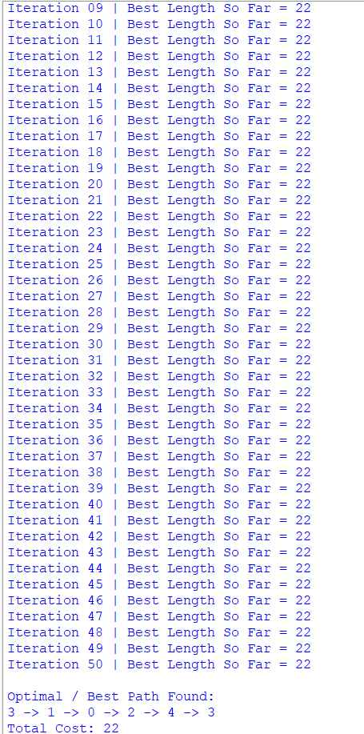

Experiment-29: to implement a simple Trust and Reputation System for service providers.
CODE:
"""
Simple Trust & Reputation System

- Providers have hidden true_quality in [0,1].
- Clients interact with providers and provide binary feedback (1=positive, 0=negative).
- Each client keeps per-provider feedback counts.
- Per-client trust score for provider p: (pos + 1) / (pos + neg + 2) (Beta(1,1) prior -> Laplace smoothing)
- Provider reputation: mean of all clients' trust scores for that provider.
- Clients choose provider with highest reputation when selecting.
"""

import random
from collections import defaultdict
from typing import Dict, List, Tuple

random.seed(123) # reproducible demo

class Provider:
def __init__(self, pid: int, true_quality: float):
self.id = pid
self.true_quality = float(true_quality) # probability of delivering positive experience
self.global_pos = 0
self.global_neg = 0

def deliver_service(self) -> int:
"""Return 1 for positive experience, 0 for negative (stochastic using true_quality)."""
return 1 if random.random() < self.true_quality else 0

class Client:
def __init__(self, cid: int):
self.id = cid
self.feedback_counts: Dict[int, List[int]] = defaultdict(lambda: [0, 0])

def give_feedback(self, provider: Provider, outcome: int):
"""Record client feedback for provider (outcome=1 or 0)"""
if outcome == 1:
self.feedback_counts[provider.id][0] += 1
provider.global_pos += 1
else:
self.feedback_counts[provider.id][1] += 1
provider.global_neg += 1

def trust_score_for(self, provider_id: int) -> float:
"""Compute per-client trust estimate for a provider with Laplace smoothing."""
pos, neg = self.feedback_counts.get(provider_id, [0, 0])
return (pos + 1) / (pos + neg + 2) # Beta(1,1) posterior mean

class TrustReputationSystem:
def __init__(self):
self.providers: Dict[int, Provider] = {}
self.clients: Dict[int, Client] = {}

def add_provider(self, pid: int, true_quality: float):
self.providers[pid] = Provider(pid, true_quality)

def add_client(self, cid: int):
self.clients[cid] = Client(cid)

def run_interaction(self, client: Client, provider: Provider):
"""One interaction: service delivered, client records feedback."""
outcome = provider.deliver_service()
client.give_feedback(provider, outcome)

def compute_reputation(self, provider_id: int) -> float:
"""Aggregate reputation as mean of all clients' trust scores for this provider."""
if not self.clients:
return 0.0
scores = [client.trust_score_for(provider_id) for client in self.clients.values()]
return sum(scores) / len(scores)

def select_best_provider(self) -> Tuple[int, float]:
"""Select provider with highest reputation; return (pid, reputation)."""
best_pid, best_rep = None, -1.0
for pid in self.providers:
rep = self.compute_reputation(pid)
if rep > best_rep:
best_pid, best_rep = pid, rep
return best_pid, best_rep

def simulate(self, rounds: int, interactions_per_round: int = 1):
"""Each round: each client selects a provider (by current reputation) and interacts."""
for r in range(1, rounds + 1):
client_ids = list(self.clients.keys())
random.shuffle(client_ids)
for cid in client_ids:
client = self.clients[cid]
best_pid, _ = self.select_best_provider()
if best_pid is None:
best_pid = random.choice(list(self.providers.keys()))
provider = self.providers[best_pid]
for _ in range(interactions_per_round):
self.run_interaction(client, provider)

def print_status(self):
print("=== Providers summary ===")
for pid, prov in self.providers.items():
rep = self.compute_reputation(pid)
print(f"Provider {pid}: true_quality={prov.true_quality:.3f}, global_pos={prov.global_pos}, global_neg={prov.global_neg}, reputation={rep:.4f}")
print(" Per-client trust scores:")
for cid, client in self.clients.items():
t = client.trust_score_for(pid)
print(f" Client {cid}: trust={t:.4f} (pos,neg)={client.feedback_counts.get(pid, [0,0])}")
best_pid, best_rep = self.select_best_provider()
if best_pid is not None:
print(f"\nSelected best provider by reputation: Provider {best_pid} with reputation {best_rep:.4f}")
else:
print("\nNo providers available.")

def demo():
# create system
sys = TrustReputationSystem()

# Add providers (id, true_quality)
sys.add_provider(1, 0.85) # high-quality provider
sys.add_provider(2, 0.60) # medium-quality
sys.add_provider(3, 0.35) # low-quality

# Add clients
num_clients = 8
for cid in range(1, num_clients + 1):
sys.add_client(cid)

# Initial state print (no interactions)
print("Initial state (no interactions):")
sys.print_status()
print("\n--- Running simulation: clients pick best provider by current reputation and interact ---\n")

# Run simulation: many rounds so reputations converge
sys.simulate(rounds=30, interactions_per_round=1)

# Final status
print("\nFinal status after simulation:")
sys.print_status()

# Show some extra summary
print("\nDetailed provider reputations (rounded):")
for pid in sys.providers:
print(f" Provider {pid}: Reputation = {sys.compute_reputation(pid):.3f}")

if __name__ == "__main__":
demo()

Output:
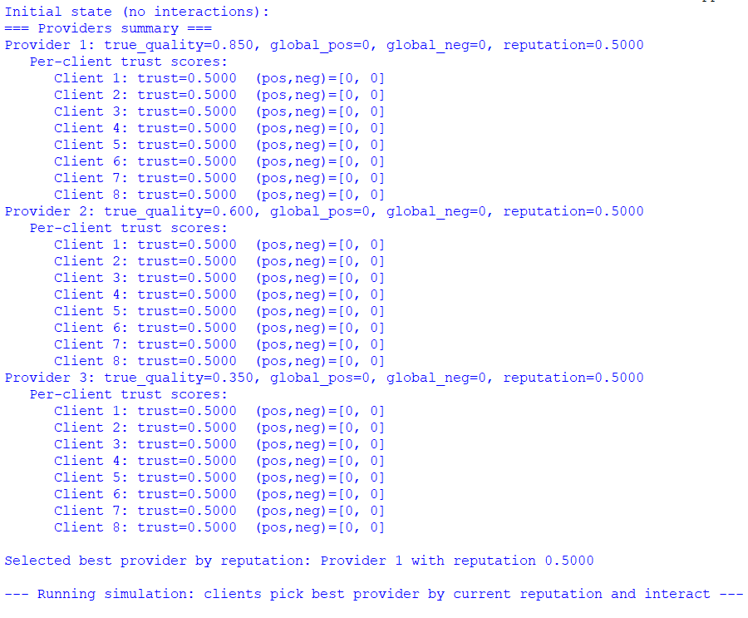
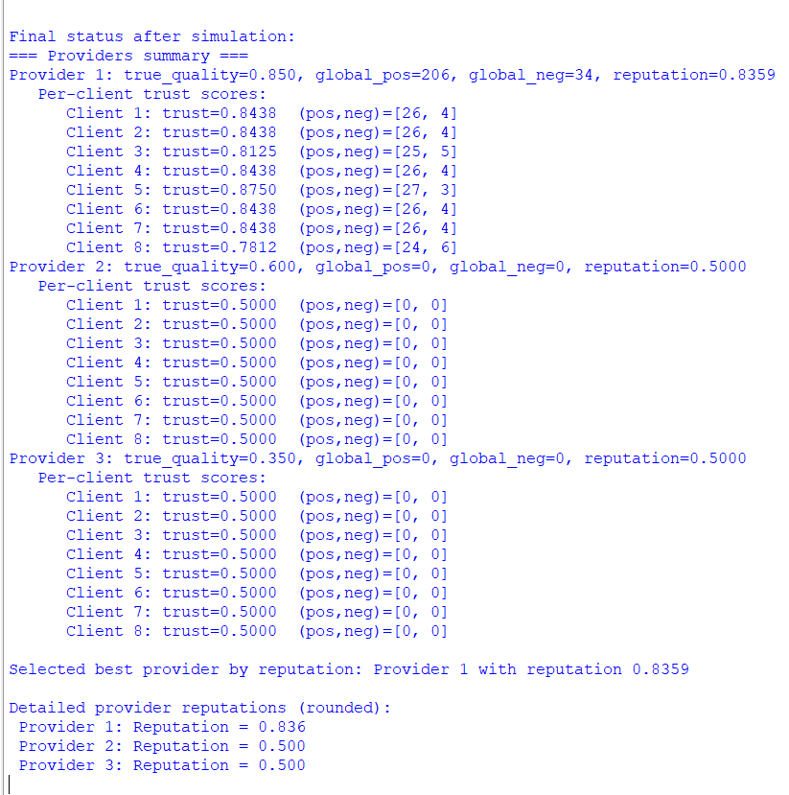

Experiment-30: Write a Python program to:
a) Parse ontology triples representing subclass relationships.
b) Build a knowledge graph (dictionary-based).
c) Support queries like:
▪ Find all subclasses of a given class.
▪ Check if one class is a subclass of another (directly or indirectly).
d) Print the results clearly.
CODE:
# ---------------- Ontology Graph Builder ----------------

# Example ontology triples (subject, predicate, object)
triples = [
("Dog", "rdfs:subClassOf", "Mammal"),
("Cat", "rdfs:subClassOf", "Mammal"),
("Mammal", "rdfs:subClassOf", "Animal"),
("Animal", "rdfs:subClassOf", "LivingBeing"),
("Fish", "rdfs:subClassOf", "Animal"),
("Shark", "rdfs:subClassOf", "Fish"),
]

# ---------------- Build Knowledge Graph ----------------
def build_knowledge_graph(triples):
graph = {}
for subj, pred, obj in triples:
if pred == "rdfs:subClassOf":
if obj not in graph:
graph[obj] = set()
graph[obj].add(subj)
return graph

# ---------------- Query Functions ----------------

# Find all subclasses (direct + indirect)
def find_all_subclasses(graph, superclass):
subclasses = set()
direct = graph.get(superclass, set())

for sub in direct:
subclasses.add(sub)
subclasses |= find_all_subclasses(graph, sub) # recursive call

return subclasses

# Check if one class is subclass of another
def is_subclass(graph, subclass, superclass):
# Direct subclass?
if subclass in graph.get(superclass, set()):
return True

# Check indirect subclasses recursively
for sub in graph.get(superclass, set()):
if is_subclass(graph, subclass, sub):
return True
return False

# ---------------- Main ----------------
if __name__ == "__main__":
graph = build_knowledge_graph(triples)
print("Knowledge Graph (Superclass → Subclasses):")
for key, value in graph.items():
print(f" {key} → {', '.join(value)}")

print("\n--- Queries ---")

# Query 1: Find all subclasses of 'Animal'
target_class = "Animal"
result = find_all_subclasses(graph, target_class)
print(f"All subclasses of '{target_class}': {', '.join(sorted(result))}")

# Query 2: Check subclass relationship
subclass, superclass = "Dog", "LivingBeing"
print(f"\nIs '{subclass}' a subclass of '{superclass}'? → {is_subclass(graph, subclass, superclass)}")

subclass, superclass = "Shark", "Mammal"
print(f"Is '{subclass}' a subclass of '{superclass}'? → {is_subclass(graph, subclass, superclass)}")

OUTPUT:
